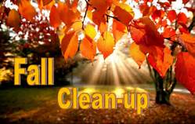

PLEASE KEEP YARDS CLEAN IN ORDER TO HELP PREVENT IT FROM BEING A FIRE OR A HEALTH HAZARD.

LET’S WORK TOGETHER TO LIVE IN A SAFE AND BEAUTIFUL COMMUNITY

TERRELL COUNTY COMMISSIONERS